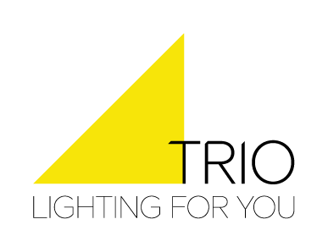

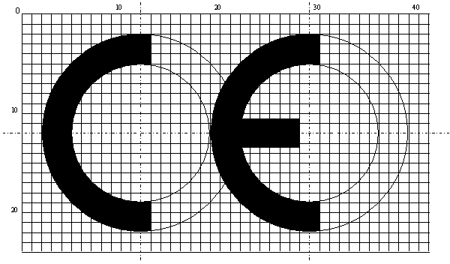
EC Declaration of Conformity

Company: | TRIO Leuchten GmbH
Address: | Gut Nierhof 17  59757 Arnsberg  Germany

This declaration of conformity is issued under the sole responsibility of the manufacturer.

Article number / description:
5179001xx portable luminaire for incandescent lamps
(xx): placeholder for item colour code

The object of the declaration described above is in conformity with the relevant Union harmonisation legislation and relevant harmonised standards:

 |  |  |  | Related regulations / standards
X | 2011/65/EU | Directive of the European Parliament and of |  | Amendment 2015/863
 |  | the council
 |  | Restriction of use of certain hazardous substances RoHs
 | 2009/125/EG | Directive of the European Parliament and of |  | 2019/2020 EU
 |  | the council
 |  | Eco design requirements
 | 2014/30/EU | Directive of the European Parliament and of |  | EN IEC 55015: 2019 + A11:2020
 |  | the council
 |  | Electromagnetic compatibility |  | EN 61547: 2009
 |  |  |  | EN IEC 61000-3-2: 2014
 |  |  |  | EN 61000-3-3: 2013
X | 2014/35/EU | Directive of the European Parliament and of | X | EN IEC 60598-1: 2021 + A11:2022
 |  | the council
 |  | Low voltage directive |  | EN IEC 60598-2-1: 1989
 |  |  | X | EN 60598-2-4: 2018
 |  |  |  | EN 62471 : 2008
 |  |  | X | EN 62493 : 2010

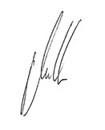
Already issued declarations of conformity lose their validity by this one.

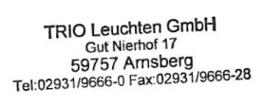  Arnsberg, 17.08.2023 |  | Der Geschäftsführer Philipp Müller
(Place, date) |  | (legally binding signature of the issuer)

This conformity certificate states the agreement with the mentioned directives, but does not assure properties as defined by the law on product liability. Doc. Rev. 07/19

